COMP Cams® Micro Surface Enhancement™

Memphis, TN – COMP Cams® is the first in the automotive aftermarket to employ a new camshaft finish technology for increased strength and performance that far exceeds traditional polishing.

Micro Surface Enhancement™ (MSE) is a finishing process that improved the traditional camshaft lobe and bearing journal through a 65-percent reduction in surface peak roughness and provides a 250-percent improvement in the effective load bearing area. Spreading the contact area between the roller and cam face allows for much higher loads and lower localized stress. Additionally, MSE utilizes uniform pressure across the camshaft lobe face that reduces the surface waviness common with other finishing techniques, such as belt polishing. The resulting camshaft surface more evenly distributes load for increased durability. MSE also removes the sharp edges and microscopic machining marks that normally result from the grinding process.

The MSE process is now standard on all COMP Cams® GM LS camshafts.
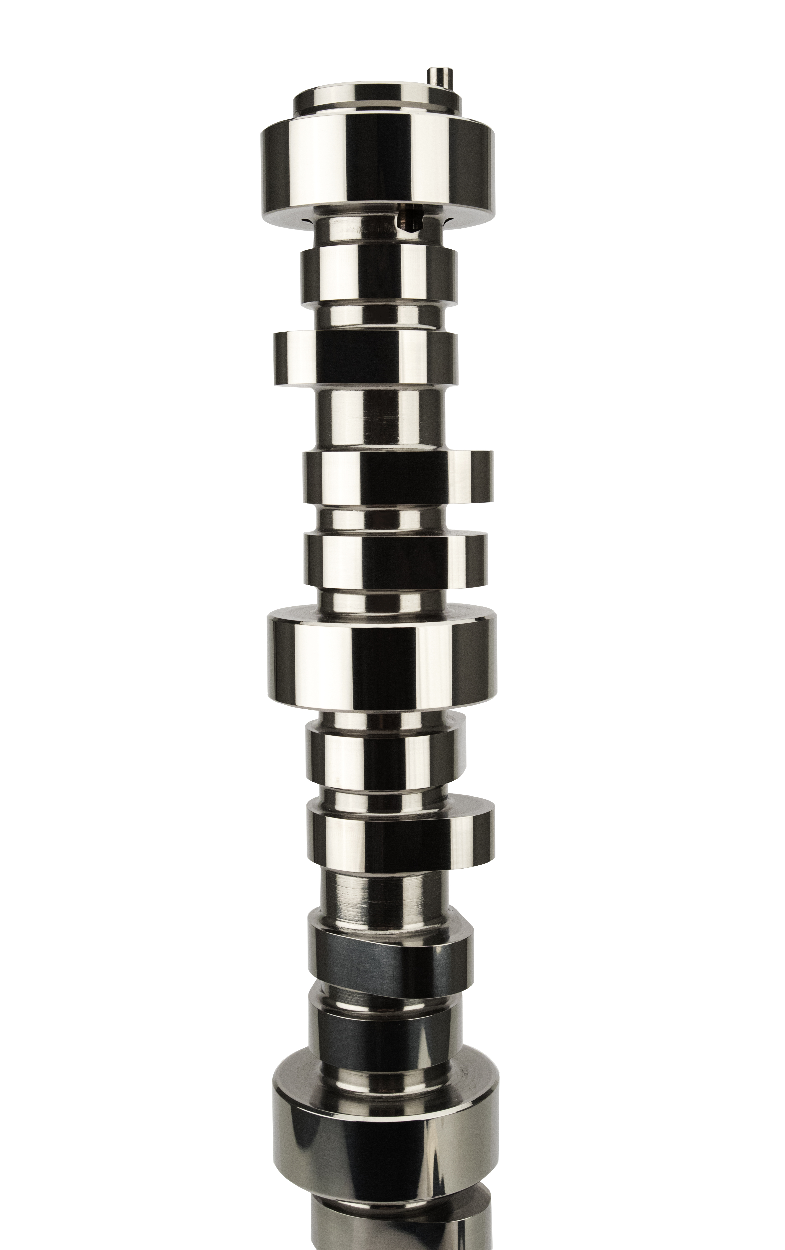
Quick Facts

Product: COMP Cams® Micro Surface Enhancement™

Social Media Pitch: COMP Cams® Micro Surface Enhancement™ finishing process improves load bearing area by 250%

Features & Benefits:
Reduces surface peak roughness of freshly ground camshaft by 65%
250% improvement in effective load bearing area to allow for higher loads
Uniform pressure reduces surface waviness for increased durability
Standard finish on all COMP Cams® GM LS cams

About COMP Cams®

Founded in 1976 and based in Memphis, TN, COMP Cams® has become the automotive performance aftermarket’s “Absolute Leader in Valve Train Technology.” Our mission is to produce the highest-performing products possible, provide superior customer service and lead the industry in technological development. Additional information about COMP Cams® and its products can be found at www.compcams.com or by calling 1.800.999.0853. You can also visit us on Facebook (facebook.com/COMPWins), Twitter (twitter.com/COMPCams), Instagram (instagram.com/compcamsofficial) and YouTube (CPGNationTV.com).

Media Contact: Cindy Bullion, cbullion@compcams.com, 901.795.2400 ext. 1643.

